PPG REQUEST FOR GBFF PROJECTS

GENERAL PROJECT INFORMATION
Project Title: | Sustainable Restoration and Conservation of Malagarasi – Moyowosi Wetland Ecosystem through an Integrated Approach
Country: | Tanzania URT | GEF Project ID:
GEF Agency(ies): | UNDP | GEF Agency Project ID: | 9967
Anticipated Executing Entity(s) and Type: | Vice President's Office (VPO) | government
Anticipated Executing Entity(s) and Type: | Ministry of Natural Resources & Tourism | government
Anticipated Executing Entity(s) and Type: | Ministry of Environment | government
GEF Focal Area(s): | Biodiversity | Submission Date: | 23 Sept 2024
Type of Trust Fund: | GBFF | Project Duration (Months) | 60
GEF Project Financing: (a) | 6,197,032 | PPG Amount (c): | 150,000
Agency Fee(s): (b) | 588,718 | PPG Agency Fee(s) (d): | 14,250
Total GEF Financing: (a+b+c+d) | 6,950,000 | Total Co-financing: | 10,000,000
Project Tags: | Support IPLC  Contributions to the implementation of:  GBF Target 1 GBF Target 2 GBF Target 3  GBF Target 4 GBF Target 5 GBF Target 6 GBF Target 7  GBF Target 8 GBF Target 9 GBF Target 10 GBF Target 11 GBF Target 12 GBF Target 13 GBF Target 14 GBF Target 15 GBF Target 16 GBF Target 17 GBF Target 18 GBF Target 19 GBF Target 20 GBF Target 21 GBF Target 22 GBF Target 23

Indicative Project Overview

Project Objective: | To ensure the Malagrasi-Muyowosi wetland ecosystem is well conserved and restored with benefits for surrounding communities from gender-responsive, participatory governance, and strengthened economic opportunities for integrity of the ecosystem.
Project Components | Component  Type | Project Outcomes | Project Outputs | Trust Fund | (in $)
 |  |  |  |  | GEF Project Financing | Co-financing
1.Strengthen institutional capacity for effective management of the wetlands | TA | - Institutional capacity for sustainable wetland management, better biodiversity protection and climate resilience strengthened  Indicator: Capacity score as measured by UNDP capacity score card; Target: TBD | 1.1.1 Develop & implement Integrated Wetland Management plan that addresses environmental and social priorities.  1.1.2. Institutional capacity developed for wetland management, biodiversity conservation, and climate change adaptation strategies - incl, LGAs TAWA, Water Basin Authorities and local communities enhanced | GBFF | 1,722,675 | 2,698,333
2. Enhance restoration of wetlands and associated ecosystems for sustainable biodiversity conservation | INV | 2.1 Alternative community livelihoods to reduce pressure on wetlands resources in the ecosystem improved.  Indicator: Number of people (50% women) directly benefiting from livelihood investments; Target: 4700  Indicator: Area under improved management to benefit biodiversity (Core indicator 4.1) Target: 270,000ha | 2.1.1 Culturally sensitive, biodiversity-compatible livelihood initiatives, (SMART agriculture, aquaculture, eco-tourism) for income generation implemented.  2.1.2. Livelihoods Action Plan developed, based on gender-responsive, and resource-use assessment, taking ecological sustainability, local knowledge, and stakeholder needs/interests into account | GBFF | 1,883,900 | 3,620,000
 | INV | 2.2 Ecosystem services and sustainable biodiversity conservation in the Malagarasi-Moyowosi wetland improved.  Indicator: Area of terrestrial protected areas under improved management effectiveness (Core indicator 1.2); Target: 3,145,352 ha.  Area of land and ecosystems put under restoration (Core indicator 3.1); Target: 4320 ha  Indicator: Greenhouse emissions mitigated under AFLOU sector (Core indicator 6.1); Target: 12MtCo2e | 2.2.1 Targeted wetland restoration initiatives that improve ecosystem health, increase biodiversity, and enhance the provision of ecosystem services in support of nature-based livelihoods implemented.  2.2.2 A gender-responsive, culturally-sensitive and socially-inclusive performance-based conservation awards system established and operationalised  to motivate sustainable local resource management, ensuring fair and equitable access by all stakeholders | GBFF | 1,722,610 | 2,698,333
3. Participatory Knowledge management, gender mainstreaming and adaptive risk management | TA | 3.1. Knowledge management practices, gender mainstreaming, and adaptive risk management strengthened.  Indicator: Level of Safeguards implementation  Target: Satisfactory | 3.1.1 Community-based tracking, monitoring system, and reporting changes in the wetland ecosystem established.  3.1.2 Project-level safeguards and risk management measures, including inter alia a gender action plan, stakeholder engagement plan (incorporating FPIC) and GRM) and a Livelihoods Action Plan developed and implemented. | GBFF | 292,254 | 380,357
4. M&E and risk management | TA | 4.1. Results and impact of interventions tracked, analysed and documented through robust M&E tools and systems, enabling adaptive management to enhance social and environmental outcomes | 4.1.1. A gender responsive project M&E plan implemented with participation of key stakeholders.  4.1.2 Digital tools and platforms incorporated to aid tracking, monitoring, and reporting on interventions in the wetland area including storage of all data, reports, and publications in a central repository.  4.1.3 PIRs, MTR and TE reports compiled timeously, and inform adaptive management decisions. | GBFF | 180,496 | 126,786
Subtotal |  |  |  |  | 5,901,935 | 9,523,809
Project Management Cost (PMC) (if this is an MTF project, please report separate PMC lines for each TF). ***If amount requested is above limits, a pop-up menu should open for the Agency to provide an explanation*** |  |  |  |  | 295,097 | 476,191
Total Project Cost |  |  |  |  | 6,197,032 | 10,000,000

Project Concept Description

In Tanzania, about 10% of the land surface is covered by freshwater wetlands, of which thousands of people, especially local communities, depend for livelihoods. The wetlands have different conservation status, whereby some are in forests and game reserves, national parks, and other protected areas, while others have no protection status. Tanzania has four designated wetlands of international importance: Malagarasi-Muyovozi, Kilombero Floodplain, Rufiji Mafia Kilwa (RUMAKI) and Lake Natron.

The Malagarasi-Muyovozi wetland is the first Ramsar site, designated in 2000. The site is extremely important, located in the northwest of Tanzania in the river basin of the Malagarasi River, Tanzania’s second largest river basin (which in turn forms over 30% of the catchment of Lake Tanganyika). The wetlands of the reserve comprise lakes and open water in the dry season, together with a permanent riverine swamp (and/or gallery forest), with large peripheral flood plains that fluctuate widely every year (depending on the amount of rainfall). These wetland habitats are surrounded by very extensive miombo woodlands and wooded grasslands. The reserve provides a crucial habitat for two threatened bird species of global significance, the Whale-headed Stork Shoebill (Balaeniceps rex) and Wattled Crane (Bugeranus carunculatus) and is an important nursery and feeding ground for a wide variety of fish species, at least 51 of which are endemic to the area. The reserve is also home to East Africa’s largest protected populations of Sitatunga (Tragelaphus spekii spekii) and small numbers of the African slender-snouted crocodile (crocodile niloticus) Furthermore, the site is important for large mammals, migratory and resident water birds, fish, and plants as well as providing significant livelihood support to local communities.

However, currently the wetland is under intense pressure caused by unsustainable human activities in the wetland and in upstream watersheds. These include unsustainable agriculture, uncontrolled irrigation, overgrazing, uncontrolled construction of fishponds, illegal fishing, and overexploitation of other wetland resources. Recently, there has been a drastic increase in irrigated land, livestock population in wetlands, and clearing of wetlands for the construction of fishponds.

The project aims to ensure the Malagrasi-Muyowosi wetland area /ecosystem is well conserved and restored and that communities living around the area benefit through gender-responsive, participatory governance and strengthened alternative economic engagement for culturally-sensitive, socially-inclusive sustainable utilization of the ecosystem. The project objective will be achieved through strengthening institutional capacity for effective participatory management of the wetland, enhancing ecologically-sustainable, inclusive livelihood programs to strengthen local economic opportunities and reduce pressure on wetland resources, and enhancing restoration of wetlands to sustain ecosystem services and biodiversity conservation. The project will ensure gender- and culturally-sensitive knowledge management, participatory monitoring & evaluation, effective gender mainstreaming and accountability to stakeholders across all project components, to optimize wetland conservation outcomes.

Tanzania is a signatory to multilateral environmental agreements (MEAs) including the Rio Conventions on Biological Diversity (CBD); Climate change (UNFCCC) and Combating Desertification (UNCCD); the Convention on Wetlands of International Importance; the Convention on International Trade in Endangered Species of Wild Fauna and Flora (CITES); and Convention on Migratory Species of Wild Animals, which this project is well aligned with and will further progress towards. Therefore, the project is anchored on SDG 15, SDG 14, CBD Kunming-Montreal Global Biodiversity Framework target 1, 2 and 3. It will contribute to four GEF core indicators 1, 3, 6 and 11; and GBFF Action Areas 1 and 2.
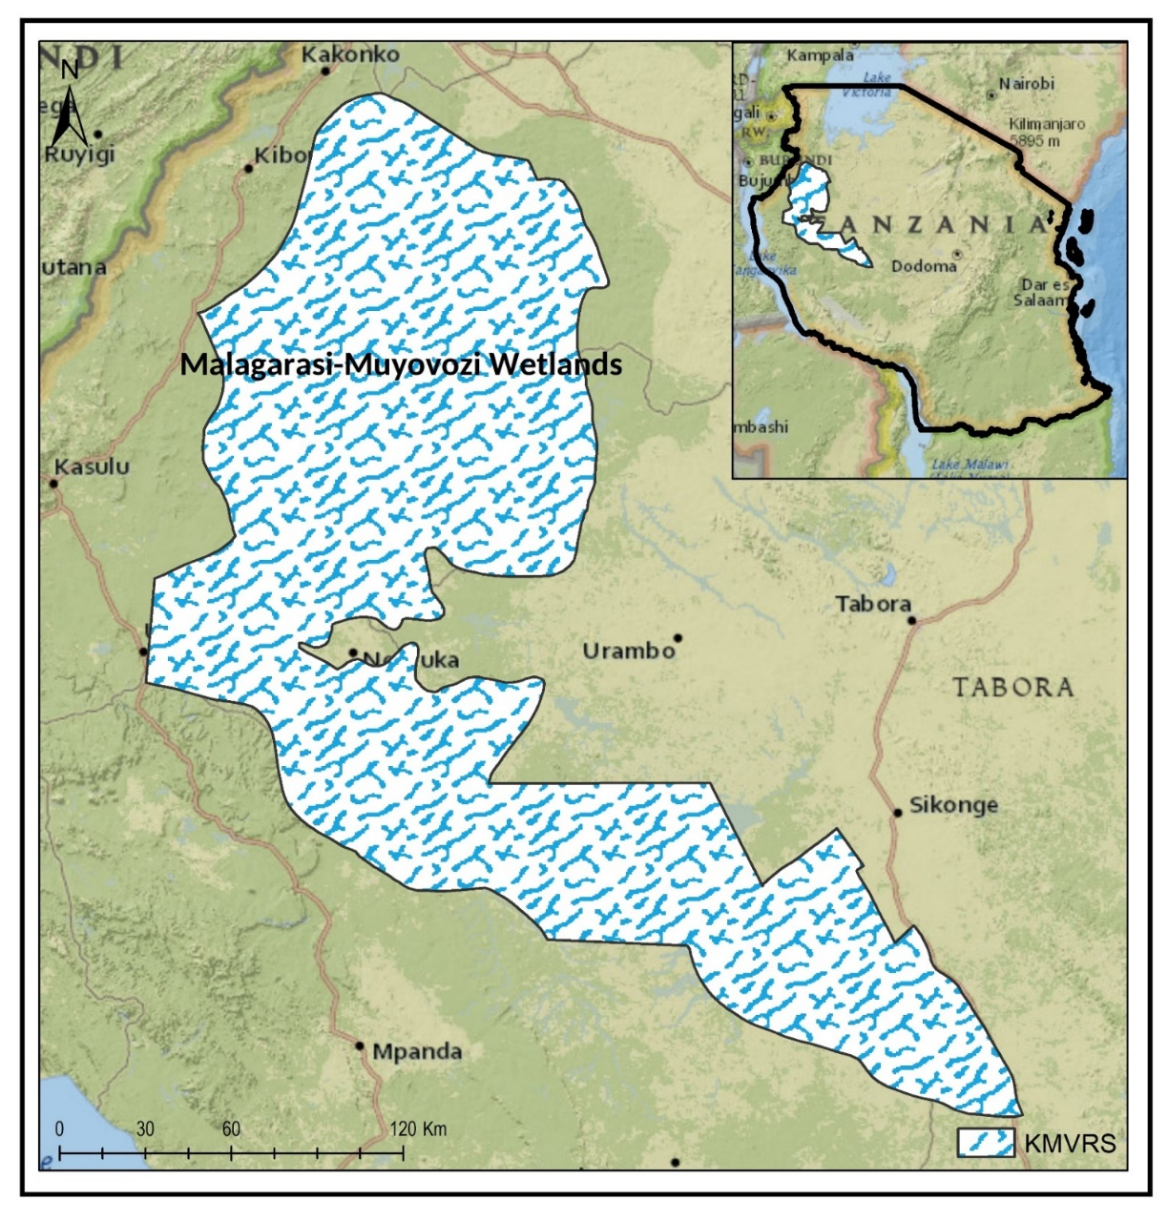
- Project Description

Wetlands of Malagarasi-Muyovosi, Kilombero Floodplain, Rufiji Mafia Kilwa (RUMAKI) and Lake Natron have been designated as wetlands of international importance under the Ramsar Convention on wetlands¹. These four wetlands are under intense pressure caused by encroachment and unsustainable human activities leading to a continuous decrease in their size due to expansion of other land uses emanating from increasing demand for arable land and settlement Figure 1: Location of the Malagarasi-Moyowosi Wetland.
This project aligns with global and national conservation frameworks that seek to ensure that all areas of important biodiversity are effectively managed for the benefit of people and nature. There are several national laws and policies that this project aligns with, including: Environment Management Act 2004, the National Environmental Master Plan for Strategic Interventions 2022-2032; The Wildlife Policy 2007; the Wildlife Policy Implementation Strategy; the National Strategy to Combat Poaching and Illegal Wildlife Trade; Human-Wildlife Conflict Management Strategy 2020-2024; Wildlife Conservation Act, Cap. 283 Revised Edition 2022; Forest Act, 2002 (Act No. 7 of 2002). The National Water Policy 2002; Water resources Management Act 2009; National agriculture Policy 2013, Fisheries Policy 2005; Livestock Policy; the national Climate Change Response Strategy, the National Biodiversity Strategy and Action Plan 2015-2020, the broader Tanzania Development Vision 2025 and the National five-year Development plan for 2021/22 to 2025/26.
Grounded by a project theory of change (figure 1) that stems from analysis of existing challenges (include unsustainable agriculture, uncontrolled irrigation, overgrazing, uncontrolled construction of fishponds, illegal fishing, and overexploitation of other wetland resources. Vulnerable communities, who are impacted by land-use conflicts and livelihoods insecurity because of climate change, resort to coping strategies that degrade important biodiversity and important areas like Malagarasi – Moyowosi wetland system.
The main barriers facing both Government and communities to address the challenges include inadequate community-level governance, weak law enforcement and monitoring. The proposed solutions are guided by the realisation that if:
- Institutional capacity for sustainable wetland management, better biodiversity protection and climate resilience are strengthened, including spatial planning capacity for wetlands management plan development.
- Gender inclusive alternative community livelihoods in the ecosystem are improved such as sustainable agriculture, aquaculture, or eco-tourism, that provide income opportunities for local communities without degrading the wetland ecosystem catalysed by private sector engagement.
- Then, threats and pressure on wetlands resources will be reduced and ecosystem services and sustainable biodiversity conservation in the Malagarasi-Moyowosi wetland are improved for resilience building.
Key assumptions underlying the theory of change include:
- Relevant institutions and stakeholders involved in the management of the Malagarasi-Moyowosi Wetland Ecosystem are willing and able to participate in capacity building initiatives, and actively apply the knowledge and skills gained to improve the management and conservation of the wetland.
- Local communities are willing to transition to alternative livelihoods and there are viable economic opportunities available that can provide sustainable income without exerting pressure on the wetland resources.
- There is sufficient local and national level coordination available to guide the restoration efforts, and the necessary resources.
- There is strong commitment from all stakeholders, including local communities and institutions, to enhance knowledge management, gender mainstreaming, monitoring and evaluation.
- Communities are willing to engage in and collaborate on Conservation initiatives,
- Government agencies and other stakeholders provide supportive policies and resources and
- External threats and disturbances are minimized, including large scale agriculture/land-use change.

All this will be achieved with engagement and leveraging the support from private sector investment in inclusive business models and nature-based financing solutions that benefit communities; then, communities will be incentivised to restore and protect degraded lands and enhance agro-pastoral co-existence. The project will strengthen community stewardship over resources and effective management of wildlife and wetlands that ensures key species are protected and resilience of the ecosystem and communities. Solutions to the existing challenges have been designed around 8 outputs which will contribute to four outcomes that are expected to achieve the project objective of ensuring the Malagrasi-Muyowosi wetland area /ecosystem is well conserved, restored and community living around the area benefits through effective gender-responsive governance, and strengthened alternative economic opportunities for integrity of the ecosystem.

The project will contribute to the achievement of a wider goal, particularly via enhanced governance and sustainable management of the wetland and key species significancy and improved livelihoods, realised through four interlinked components.

Component 1: Strengthen Institutions' capacity for effective management of the wetlands.
This component will focus on development and implementation of a comprehensive wetland management plan that incorporates best practices for biodiversity conservation, climate change mitigation, and sustainable resource use. It will also cover capacity building through provision of training programs that will be conducted for institutional staff and local community members to enhance their skills and knowledge in wetland management, biodiversity conservation, and climate change adaptation strategies. It will also cover provision of equipment and working gears to communities, local authorities and relevant agencies for managing and protecting the wetland.

Component 2: Enhance restoration of wetland and associated ecosystems to promote biodiversity conservation
The project will promote sustainable alternative livelihood options for local economic sustenance to reduce pressure on wetland resources. Alternative livelihood options to be supported include sustainable agriculture, aquaculture, or eco-tourism, that provide income opportunities for local communities without degrading the wetland ecosystem. Major efforts will revolve around comprehensive stakeholder engagement and consultation in line with the project's Community Engagement Plan (applying FPIC as appropriate), and implementation of culturally sensitive capacity building and training for local communities to equip them with the skills and knowledge needed to pursue these alternative livelihoods, whilst respecting their traditional knowledge, needs and interests. The private sector partners will be crucial in supporting diversification of livelihood options that are nature positive such as tourism (include photographic, sport fishing, hunting, bird watching). Innovative financing mechanisms such as payment for ecosystem services, potential for harnessing carbon-based financing, conservation bonds etc., will be explored by the project, ensuring that robust impact assessments and safeguards measures are emplaced.
In addition, targeted wetland restoration projects that improve ecosystem health, increase biodiversity, and enhance the provision of ecosystem services to mitigate resource use conflicts will be supported. Development and implementation of wetland management will be emphasized to ensure land outside the protected area is put under better management. Furthermore, the component addresses the complex challenges of land use planning and management with community engagement. While village land-use plans designate wise use of the wetlands areas, informal practices and parallel governance systems have undermined conservation efforts. Remote sensing and surveys to confirm forest degradation will be necessary assessment and as will be continuous monitoring of the wetland. The CSOs will have an increasing role in supporting each community play an effective part in implementing the land management plans.
Component 3: Knowledge management, gender mainstreaming
The project will promote development and implementation of a comprehensive knowledge management system that facilitates the sharing and utilization of information related to the conservation of the wetland. The project will mainstream gender and social inclusion into all aspects of project design and implementation in culturally appropriate ways. Women and youth will be encouraged to participate in all stages of the project cycle to enable them to acquire greater roles in environmental stewardship, and greater financial independence. Project-level safeguards and risk management measures, including gender action plan and stakeholder engagement plan will be developed and implemented.

Component 4: Monitoring and evaluation enhanced.
The project will support establishment of robust participatory monitoring and evaluation mechanisms that track the progress of conservation initiatives, assess and mitigate their impact, and inform future decision-making and adaptive management strategies. Project-level monitoring and evaluation will be undertaken in compliance with UNDP/GEF requirements as outlined in the UNDP POPP (including guidance on GEF project monitoring) and UNDP Evaluation Policy. Collaboration with adjacent protected areas under TAWA, TFS, TANAPA, and local authorities is essential for effective implementation of the project.

Contribution to Global Environmental Benefits:

The GEF investment will make a significant contribution to reducing threats and pressure on wetlands resources which will result in improved ecosystem services for sustainable biodiversity conservation in the Malagarasi-Moyowosi wetland. The project contributes to GBF target 1: Plan and Manage all Areas to Reduce Biodiversity Loss; target 2: Restore 30% of all Degraded Ecosystems Target 3: Conserve 30% of Land, Waters and Seas and Target 22: to ensure participation in decision-making and access to justice and information related to biodiversity for all. Further, the project contributes to GEF core indicators below:

Core indicator 1.2: Area of terrestrial protected areas under improved management effectiveness (3,145,352 ha.) This includes Moyowosi Game Reserve (600,000ha), Ugalla River National Park (386,500) Ugalla Game Reserve (757,736), Luganzo-Tongwe Game Reserve (574,616) Kigosi Forest Reserve (826,500)

Core indicator 3.1: Area of land and ecosystems put under restoration (4320 ha). This includes 1400ha-Tabora, Kaliua district, Katavi, Mlele district (1160ha); and Kigoma, Uvinza district (1740ha).

Core indicator 4.1: Area under improved management to benefit biodiversity (270,000ha). The Project will contribute to improved land management practices in villages -adjacent to PAs. The selection of the areas in the wetland (i.e., village land that directly abuts the PA boundaries) are spatially focused on the land designated for use as plantations, woodlots, forest reserves and crop farming within these villages.

Core indicator 6.1: Greenhouse emissions reduced under AFLOU sector (12MtCoe). This is based on 14320ha restored in the 3 regions of Tabora, Katavi and Kigoma.

Core indicator 11: The project will deliver social and economic benefits to at least 78,500 individuals of whom at least 30% are women) equivalent to 27.6% of the population in the target communities who will be engaged in project activities (including training capacity development, tourism enterprises, sustainable Agricultural practices law enforcement, education and awareness-raising).

Diagram 1 below summarizes the project theory of change, illustrating overall project logic, Objective, components, outcomes, outputs, the assumptions necessary for its success, and the barriers the project aims to address and challenges.
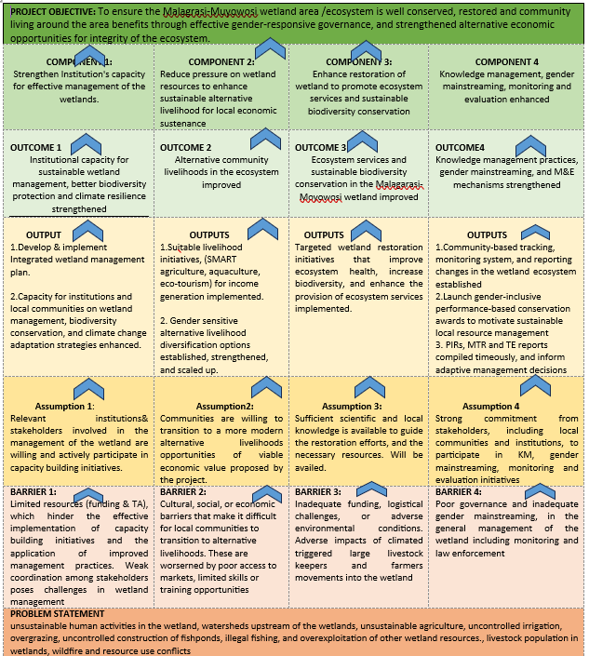
Figure 1 Theory of Change

PROJECT FINANCING TABLES

GEF Financing Table
Indicative Trust Fund Resources Requested by Agency(ies), Country(ies), Focal Area and the Programming of Funds
GEF Agency | Trust Fund | Country/  Regional/ Global | Focal Area | Programming  of Funds
 |  |  |  |  | GEF Project Grant | Agency Fee | Total  GEF Financing
UNDP | GBFF | Tanzania | Biodiversity | GBFF Tranche one | 3,523,020 | 334,687 | 3,857,707
UNDP | GBFF | Tanzania | Biodiversity | GBFF Tranche one | 2,674,012 | 254,031 | 2,928,043
Total GEF Resources |  |  |  |  | 6,197,032 | 588,718 | 6,785,750

Project Preparation Grant (PPG)
Is Project Preparation Grant requested? Yes No
If yes: fill in PPG table (incl. PPG fee)
GEF Agency | Trust Fund | Country/  Regional/  Global | Focal Area | Programming  of Funds | (in $)
 |  |  |  |  | PPG | Agency  Fee | Total PPG Funding
UNDP | GBFF | Tanzania | Biodiversity | GBFF Tranche one | 150,000 | 14,250 | 164,250
Total PPG Amount |  |  |  |  | 150,000 | 14,250 | 164,250

Sources of Funds for Country STAR Allocation (only for Multi-Trust Fund projects where GEF TF is included)
GFEF Agency | Trust Fund | Country/  Regional/Global | Focal Area | Source  of Funds | Total
 |  |  |  |  | N/A
Total GEF Resources

Indicative Action Area Elements
Programming Directions | Trust Fund | (in $)
Programming Directions | Trust Fund | GEF Project Financing | Co-financing
Action Area 1 | GBFF | 3,523,020 | 7,000,000
Action Area 2 | GBFF | 2,674,012 | 3,000,000
Total Project Cost |  | 6,197,032 | 10,000,000
Amount of resource allocated to support actions by IPLCs for the conservation, restoration, sustainable use and management of biodiversity: 2,674,012.
***POP-UP material start
In line with the aspirational 2030 programming share of 20% of GBFF resources to support actions by IPLCS for the conservation, restoration, sustainable use and management of biodiversity, please provide the amount of GBFF project financing, if any, the project plans to allocate to support such actions.
***POP-UP material ends

Indicative Co-financing

Sources of Co-financing | Name of Co-financier | Type of Co-financing | Investment  Mobilized | Amount ($)
Recipient Government | Ministry of Natural Resources and Tourism (MNRT), | In-kind | Recurrent | 10,000,000
Total Co-financing |  |  |  | 10,000,000

RESULTS INDICATOR TABLE
As per the GBFF Programming Directions, the following subset of the current suite of the GEF TF Core Indicators is used to monitor implementation performance of the GBF Fund: 1,2,3,4,5,6, 11 and all their sub indicators; 8; 9 and its sub indicators 9.4 and 9.5 (see Annex 3 of the Programming directions). Projects are encouraged to capture any co-benefits from project interventions on other GEF core indicators.

Additional indicators will be introduced to monitor policy elements of projects supported by the GBF Fund. They may draw on the monitoring framework for the Kunming-Montreal Global Biodiversity Framework once it is agreed.

Project Core Indicators |  | Expected at CEO Endorsement
1 | Terrestrial protected areas created or under improved management (hectare) | 3,145,352
2 | Marine protected areas created or under improved management (hectare)
3 | Area of land and ecosystems under restoration (hectare) | 4,320
4 | Area of landscapes under improved practices (hectare) | 270,000
5 | Area of marine habitat under improved practices (hectare)
6 | Greenhouse Gas Emissions Mitigated (metric ton of CO₂e) | 12MtCO2e
7 | Shared water ecosystems under new or improved cooperative management (count)
8 | Globally over-exploited marine fisheries moved to more sustainable levels (metric ton)
9 | Chemicals of global concern and their waste reduced (metric ton of toxic chemicals reduced)
10 | Persistent organic pollutants to air reduced (gram of toxic equivalent gTEQ)
1 | People benefiting from GEF-financed investments disaggregated by sex (count) | 78,500 (28,273W: 50,227M)

National Environmental Master Plan for Strategic Interventions (2022-2032)

